Project Planning Phase
Project Planning Template (Product Backlog, Sprint Planning, Stories, Story Points)
Date | 5 September 2026
Team ID | SWUID2026190359
Project Name | Metro Ticket Generating System in ServiceNow
Maximum Marks | 5 Marks

Product Backlog, Sprint Schedule, and Estimation (4 Marks)
The following backlog and sprint schedule are prepared for the Metro Ticket Generating System in ServiceNow. Story points use the requested Fibonacci-style values: 1, 2, 3 and 5.
Sprint | Functional Requirement (Epic) | User Story Number | User Story / Task | Story Points | Priority | Team Members
Sprint-1 | Metro Station Setup | USN-1 | As a user, I can select my Starting From metro station. | 2 | High | Individual
Sprint-1 |  | USN-2 | As a user, I can select my Going To metro station. | 1 | High | Individual
Sprint-1 | Journey Details | USN-3 | As a user, I can select Single Journey or Return Journey. | 3 | High | Individual
Sprint-1 | Passenger Details | USN-4 | As a user, I can select the number of passengers. | 3 | High | Individual
Sprint-1 | Fare Calculation | USN-5 | As a user, I can see the fare calculated automatically based on route, journey type and passenger count. | 3 | High | Individual
Sprint-2 | Payment | USN-6 | As a user, I can select UPI, CARD or Others as the payment mode. | 2 | Medium | Individual
Sprint-2 | Digital Ticket | USN-7 | As a user, I can view my completed metro booking details. | 3 | High | Individual
Sprint-2 | QR Ticket | USN-8 | As a user, I can generate and view a QR code for my metro ticket. | 3 | High | Individual
Sprint-2 | Validation | USN-9 | As a user, I can receive validation when required or invalid booking information is entered. | 2 | Medium | Individual
Sprint-2 | Service Portal | USN-10 | As a user, I can book a metro ticket through the ServiceNow Service Portal. | 5 | High | Individual
Sprint-2 | Testing & Refinement | USN-11 | As a user, I can complete the complete ticket-booking flow successfully. | 5 | High | Individual

Project Tracker, Velocity & Burndown Chart: (4 Marks)
Sprint | Total Story Points | Duration | Sprint Start Date | Sprint End Date (Planned) | Story Points Completed (as on Planned End Date) | Sprint Release Date (Actual)
Sprint-1 | 12 | 6 Days | 05 Sep 2026 | 10 Sep 2026 | 12 | Planned
Sprint-2 | 20 | 6 Days | 11 Sep 2026 | 16 Sep 2026 | 20 | Planned

Velocity:
Velocity is calculated as Total Story Points Completed divided by the Number of Sprints.
Sprint 1 = 12 Story Points
Sprint 2 = 20 Story Points
Total Story Points = 12 + 20 = 32
Number of Sprints = 2
Velocity = 32 / 2 = 16 Story Points per Sprint
Planned average points per day = 16 / 6 ≈ 2.67 Story Points per Sprint-day.
Burndown Chart:
A burndown chart represents the amount of work remaining against project time. The chart below shows the planned reduction of the 32 story points across the two sprints.
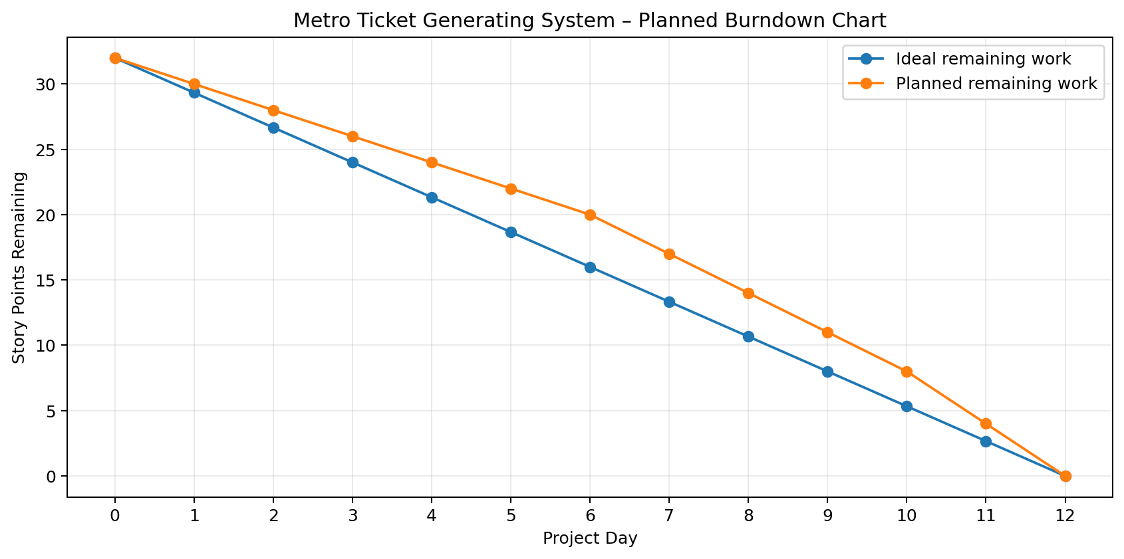
Note: The tracker and burndown values are planned values for project documentation. Actual completed story points and actual release dates should be updated after each sprint.
References:
Atlassian Agile project management concepts – project planning, epics, sprints, estimation and burndown charts.
Visual Paradigm – Scrum and burndown chart concepts.

